**Temperature Sensor**

**Definition**:

A temperature sensor measures the temperature of an object or environment. Temperature sensors are vital in IoT applications because they allow systems to monitor and respond to temperature changes in real-time. These sensors often interface with microcontrollers or IoT platforms to relay data to other systems for automatic regulation.

Working Principle:

These sensors work by detecting the change in electrical resistance, voltage, or current caused by temperature variation. Common types include thermistors, thermocouples, and RTDs (Resistance Temperature Detectors).

Applications:

* Smart thermostats
* Industrial temperature monitoring
* Environmental monitoring (weather stations)
* Home automation systems

Circuit diagram:

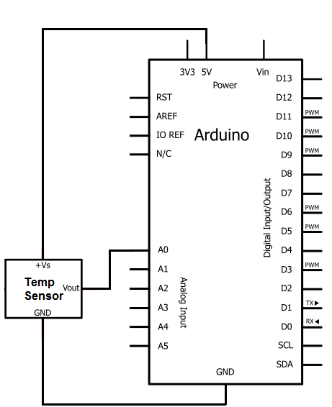

**Humidity Sensor**

Definition:

A humidity sensor measures the amount of water vapor in the air.These sensors are often used in environments where humidity levels directly affect the performance of the system or the comfort of its users. They are commonly employed in places where moisture can cause damage to electronics or affect processes.

Working Principle:

Humidity sensors typically use capacitive or resistive materials to detect changes in moisture levels. Capacitive sensors measure the change in capacitance due to moisture absorption, while resistive sensors measure the change in resistance as humidity levels vary.

Applications:

* HVAC (Heating, Ventilation, and Air Conditioning) systems
* Weather stations
* Greenhouses and agriculture
* Smart homes (e.g., in air purifiers and dehumidifiers)

Circuit diagram:

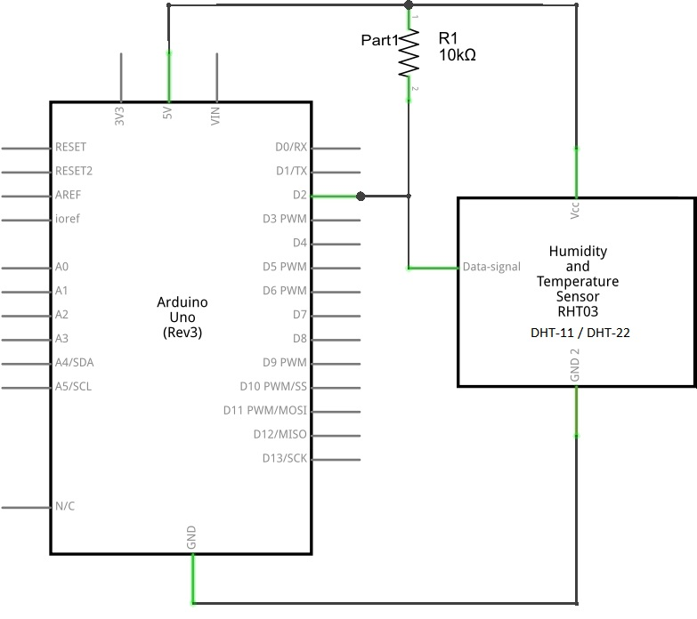

**Proximity Sensor**

Definition:

Proximity sensors detect the presence or absence of an object within a certain range without physical contact. Proximity sensors are essential in automation for detecting the position of objects without physical contact. Their non-contact nature increases their lifespan and reliability, particularly in harsh environments

Working Principle:

These sensors use electromagnetic fields (inductive), capacitance, or light (optical) to detect objects. When an object enters the sensor's detection range, it causes a change in the sensor’s output.

Applications:

* Security systems (motion detection)
* Smart home automation (automated lighting)
* Industrial automation (machine part detection)
* Mobile devices (screen lock/unlock)

Circuit diagram:

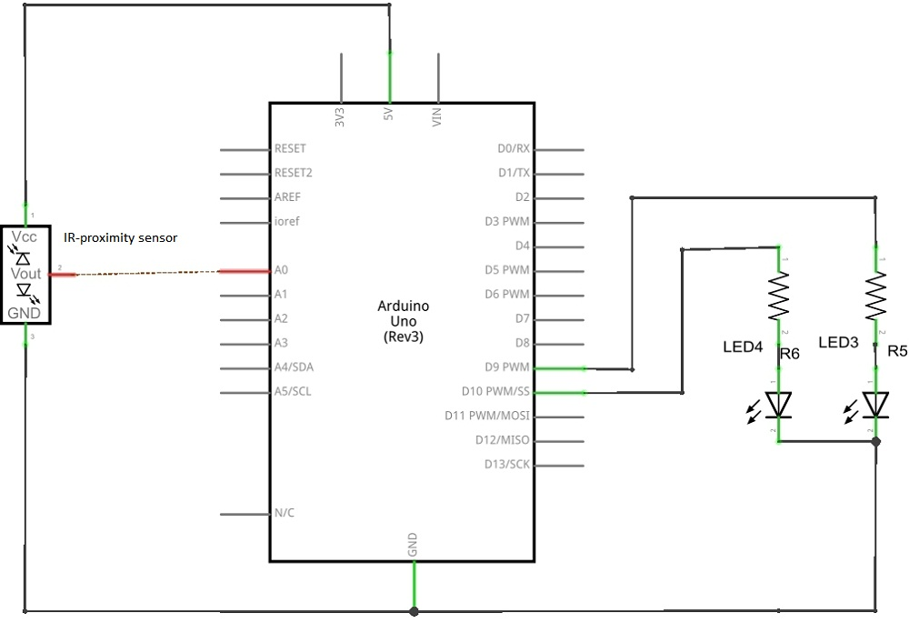

**Pressure Sensor**

Definition:

A pressure sensor measures the force applied to a surface, typically the air or liquid pressure. Pressure sensors are essential for monitoring the physical forces acting on systems, especially in fluid or air systems. By detecting changes in pressure, they ensure that systems operate within safe limits.

Working Principle:

Pressure sensors often use piezoelectric materials or strain gauges. The sensor detects changes in resistance or capacitance caused by the deformation of a diaphragm due to pressure changes.

Applications:

* Weather stations
* Industrial machinery monitoring
* Automotive systems (tire pressure monitoring)
* Water level monitoring

**Light Sensor**

Definition:

Light sensors detect light intensity or the presence of light in an environment. Light sensors are critical in energy-saving applications. They can adjust light intensity in a room or outdoor setting, based on available natural light. These sensors are typically integrated with smart lighting systems

Working Principle:

Light sensors, such as LDR (Light Dependent Resistor) or photodiodes, detect light levels by measuring the change in resistance or current when exposed to light.

Applications:

* Smart lighting systems (automatic dimming)
* Outdoor lighting systems
* Camera systems (automatic brightness adjustment
* Agricultural systems (monitoring sunlight)

Circuit diagram:

